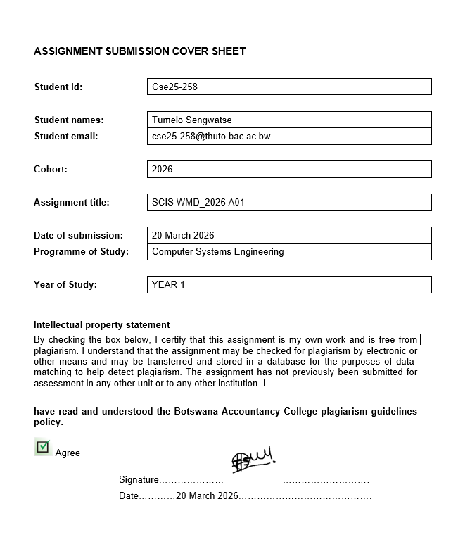

PART A — WEBSITE PLANNING & DOCUMENTATION

1. Website Specifications

TechHive Botswana is a computer and electronics retail store based in Gaborone. The website I will be creating for them will act as an online product catalogue where customers will be able to browse products, get company information, and send enquiries without visiting the physical store.

The main goals of the site are to give the business a professional web presence, display products with clear images and pricing, and allow customers to contact the store easily through an online form. The site also aims to build trust with new visitors by presenting the brand consistently across all pages.

The target audience is mainly students, young professionals, and small business owners between the ages of 16 and 45, based in urban areas of Botswana such as Gaborone and Francistown. Some users will be technically confident — like IT students or professionals — while others may be first-time buyers with little technical knowledge. Because of this mix, the site is designed to be straightforward to navigate, written in plain language, and free of unnecessary technical jargon.

Most users will visit from either a laptop or a smartphone, so the layout is designed to work well on both. The content is informational and commercial — product listings with images and pricing, a company background page, support FAQs, and an enquiry form. Content is kept concise and easy to scan, with clear headings and enough spacing to avoid a cluttered appearance.

2. Information Design & Taxonomy

TechHive Botswana uses a hierarchical structure, where all pages branch from the homepage and are reachable through a navigation bar that appears at the top of every page. No content takes more than three clicks to reach from anywhere on the site.

The site has five pages:

- Home (index.html) — landing page with a hero banner, product categories, and featured products.
- Products (products.html) — full product catalogue organised by category, with images and pricing.
- About Us (about.html) — company background, mission statement, and team information.
- Support (support.html) — FAQs and basic help resources for customers.
- Contact (contact.html) — enquiry and feedback form with HTML5 field validation.

The navigation bar is the same on every page and links to all five sections, keeping the user oriented at all times. The site map below shows the full structure and navigation paths as well as the storyboard flowchart.

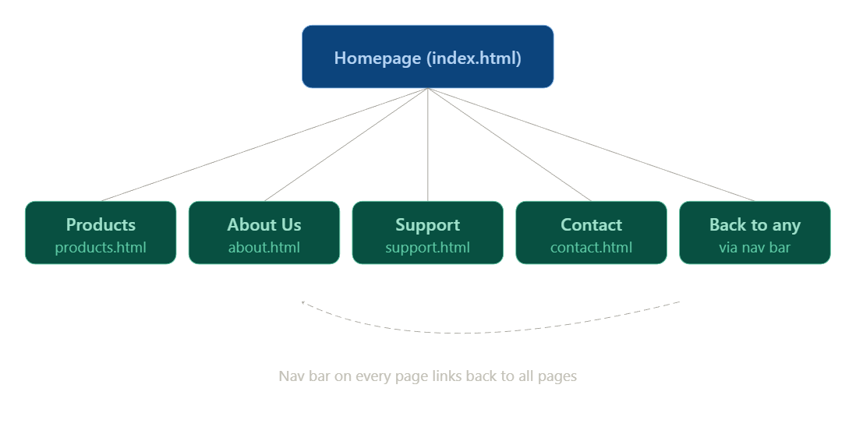
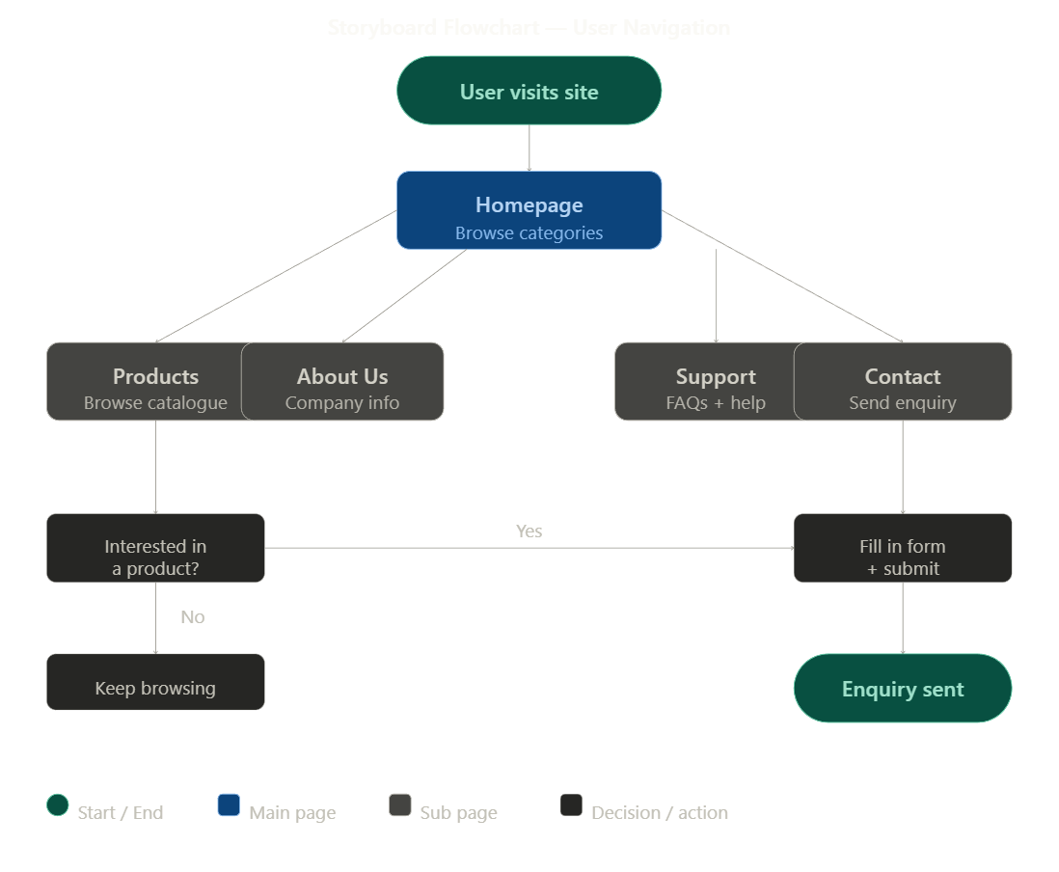

3. Page Template Design

Every page on the TechHive site will use the same template. The layout will be built with HTML5 semantic elements — header, nav, main, and footer — giving each page a clear, consistent structure. No div tags will be used for layout.

The wireframe below shows how the template is divided.
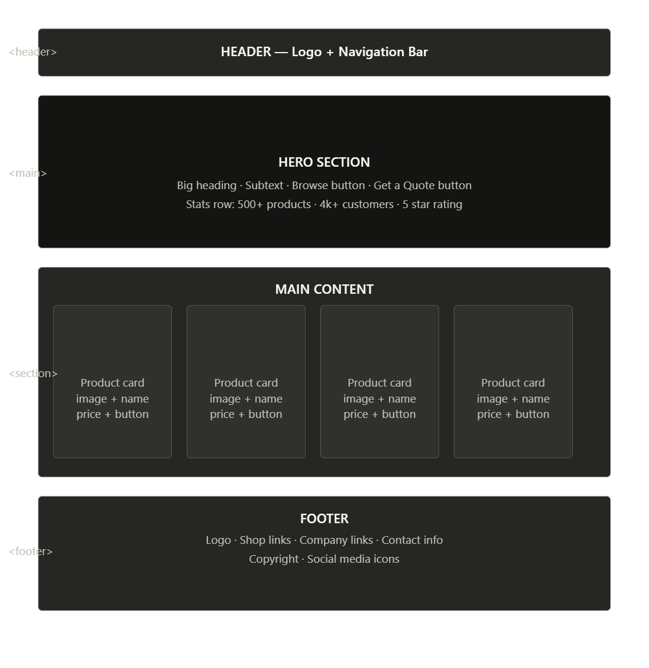

<header> — TechHive logo, site name, and tagline
<nav> — Home | Products | About | Support | Contact
<main> — Hero banner on homepage, or page content: product cards, text, images
<footer> — Contact details, social links, copyright notice

All colours, fonts, spacing, and layout rules will be defined in a single external CSS file. White space will be used deliberately between the nav and content, between product cards, and between footer columns to keep the layout clean. The product page will use a CSS grid so cards adjust from one column on mobile to three or four columns on wider screens.

4. Technical Brief

The site will be built with HTML5 for structure and CSS3 for all styling. No JavaScript will be used. Every HTML file will include a <!DOCTYPE html> declaration, use lowercase tags, properly nested elements, and include alt, width, and height attributes on every image.

All CSS will be written in one external file called styles.css, linked in the head of every page. Bootstrap 5 will be loaded via CDN to handle the responsive grid and mobile navigation bar.

VS Code: main code editor for writing and managing all HTML and CSS files. It will be used with the Live Server extension to preview changes in real time.
GIMP: will be used to create and optimise all site images including the hero background, product images, and logo. Photos will be saved as JPEG and the logo as PNG.
Bootstrap 5 (CDN): will provide the responsive grid and navigation components without needing extra files downloaded or uploaded.
Google Chrome DevTools: will be used to test the layout at different screen sizes and inspect CSS during development.
Git & GitHub: will be used for version control throughout development and to deploy the site to GitHub Pages.
W3C Validators: HTML and CSS will both be validated using the W3C tools before final submission.

Project folder structure:

File / Folder | Purpose
index.html | Homepage
products.html | Product catalogue page
about.html | About Us page
support.html | Support and FAQ page
contact.html | Contact and feedback form
css/styles.css | External stylesheet for all pages
images/ | All site images — hero, products, logo

5. Quality Assurance

The site will be tested across five browsers: Google Chrome, Mozilla Firefox, Microsoft Edge, Opera, and Safari. Each page will be checked for layout consistency, correct image loading, working navigation links, and form behaviour. Any differences found between browsers will be fixed in the CSS before submission.

Responsive testing will be done using Chrome DevTools at three screen widths: 320px for mobile, 768px for tablet, and 1280px for desktop. The main things to be checked at each size are whether the navigation collapses on mobile, whether product cards stack correctly, and whether images scale without overflow.

All HTML and CSS files will be validated using the W3C Markup Validation Service and W3C CSS Validation Service. Any errors found will be fixed before pushing to GitHub Pages.

All internal links will be manually tested across every page to confirm there are no broken links. The site will also be opened directly from the GitHub Pages URL to confirm it loads correctly before submission.

6. Publishing & Promotion

The website will be hosted on GitHub Pages. The repository will be named using the SCIS student number and GitHub Pages will be enabled from the repository settings after the first push. All filenames will be lowercase with no spaces, and the folder structure will keep HTML files, the CSS folder, and the images folder separate so relative paths work correctly on both the local machine and the live server.

Git commands used to deploy the site:

Command | What it does
git init | Creates a local Git repository in the project folder
git add . | Stages all HTML, CSS, and image files for commit
git commit -m "message" | Saves a snapshot of the project with a description
git remote add origin [URL] | Links the local repo to the GitHub repository
git push -u origin main | Uploads files to GitHub and triggers GitHub Pages
git pull | Pulls any remote changes back to the local machine

Live site URL: https://cse25-258.github.io/WMD-Assignment/

7. Future Developments / Recommendations

The TechHive website will be a static HTML and CSS site. There are a few clear ways it could be improved in future versions.

The most immediate future addition would be JavaScript. Initially the mobile nav will depend entirely on Bootstrap's toggle, the contact form has no client-side validation, and the product page has no filter. JavaScript would allow all of these to be built from scratch, giving more control over how each feature behaves and removing the reliance on Bootstrap.

A bigger step would be turning the site into a working e-commerce platform. This would need a backend — something like Node.js or PHP — with a database to manage products, stock, and orders. A local payment option like Orange Money or FNB eWallet could be added so customers can pay online instead of just submitting an enquiry.

The background images on the site will be generated programmatically. Replacing them with real product photography in future would make the site look more genuine and professional, which would improve how customers perceive the brand.

Finally, adding a simple content management system would let non-technical staff update product listings and prices without needing to edit any code, which would be essential for a real business deployment.

